Weekly report

1. **My *Goals* from last week**
   1. Create Mechanism to utilize force sensor
   2. Win VEX competition in Oklahoma
2. **My *Accomplishments* this week**
   1. Project 1: <Kilo-bot Force Measurement>
      1. E-mailed Ashwin/Dr Becker about force sensor sensor
         1. Determined that the force sensor is probably not sensitive enough for a single kilobot
         2. Discussed the specifications needed for a new sensor
         3. I realized I got measurements and then never sent them to Ashwin so I spent some of the week waiting for a response that would never come.
      2. Measured kilobots
         1. I measured the width and height of robots so we could figure out sensing area and how many kilobots would be on a bar at once
         2. 21 mm to upper lip, 33 mm diameter

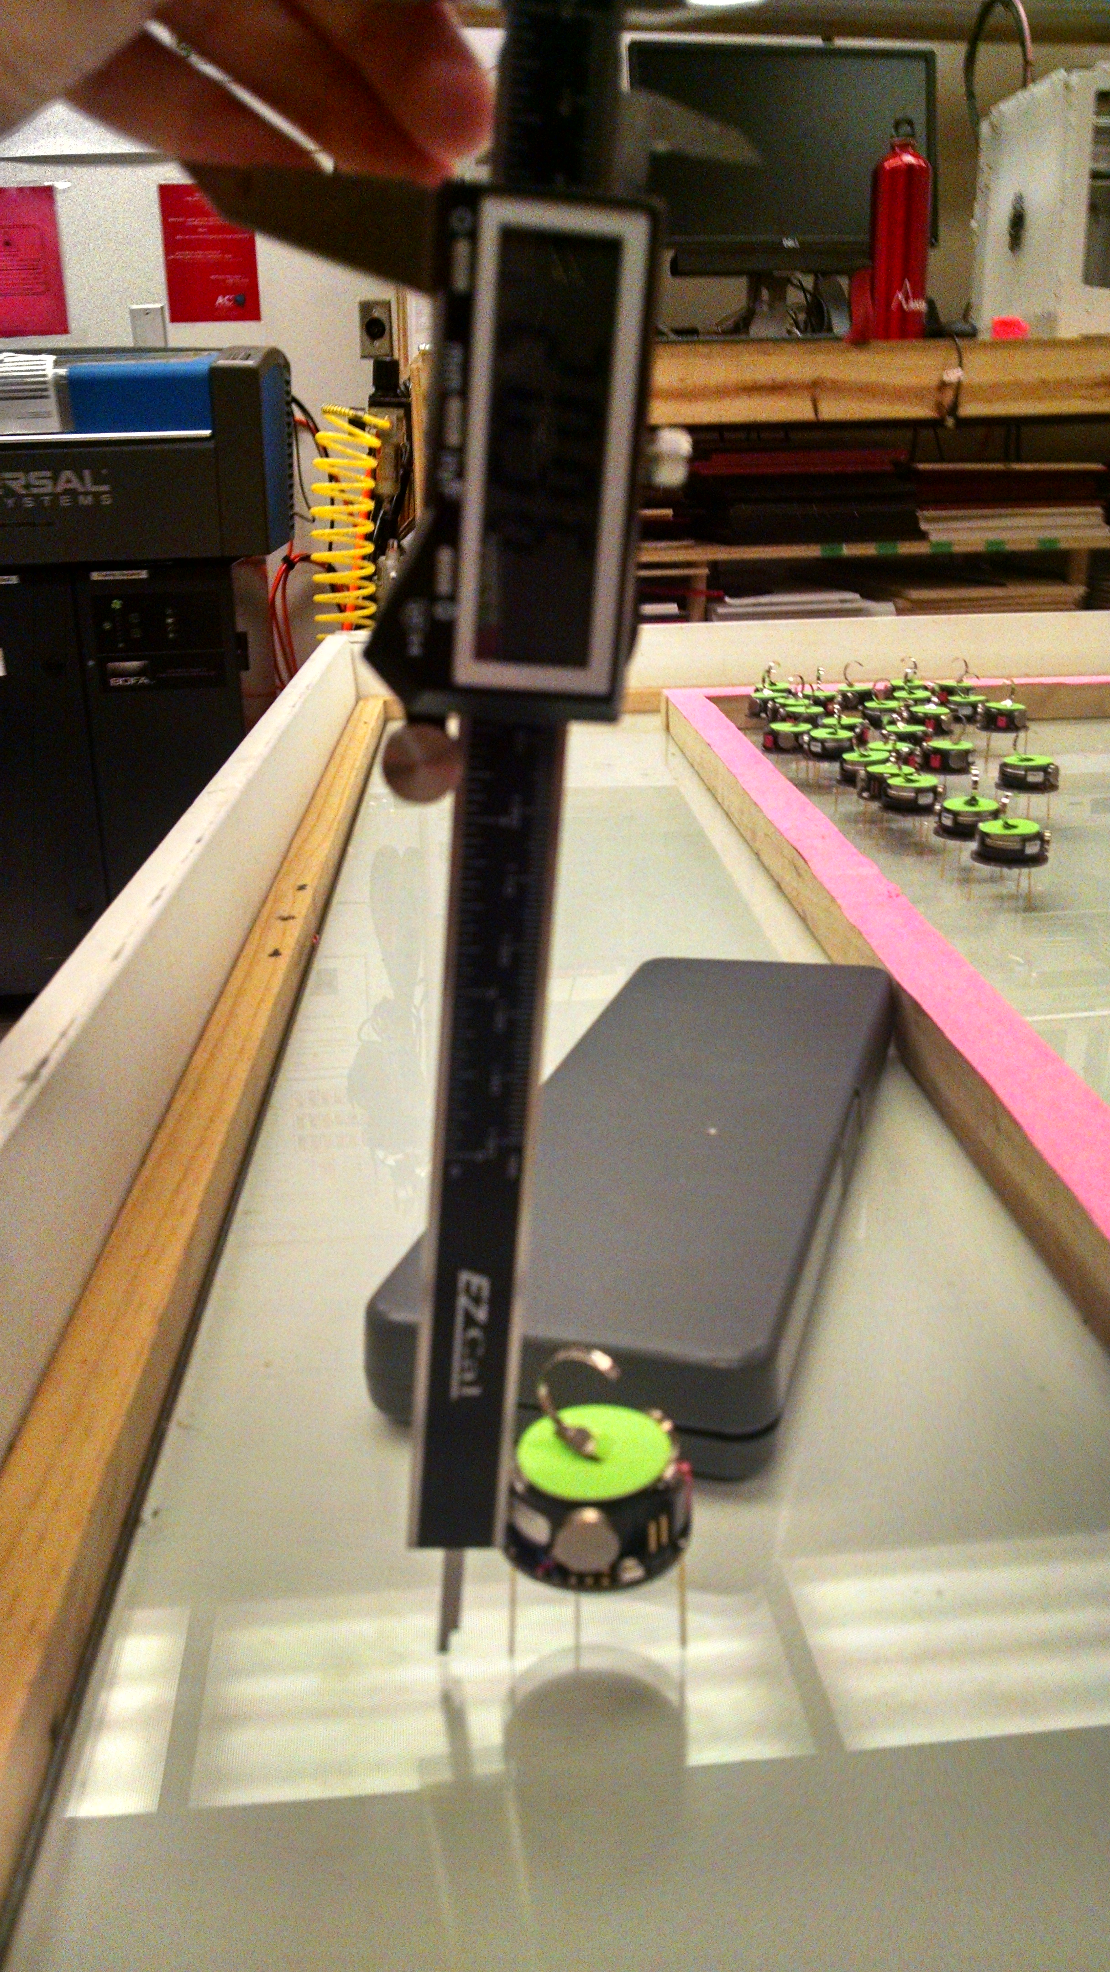

Figure - Approximately 21 mm to lip that sticks out

* 1. Project 3: <VEX Competition>
     1. Compiled a logbook so we could qualify for winning Excellence award
     2. Road Trip from Houston,TX to Muskogee, Oklahoma
     3. Robot went undefeated at the competition
     4. Awarded Tournament Champion award and World Qualifying Excellence award

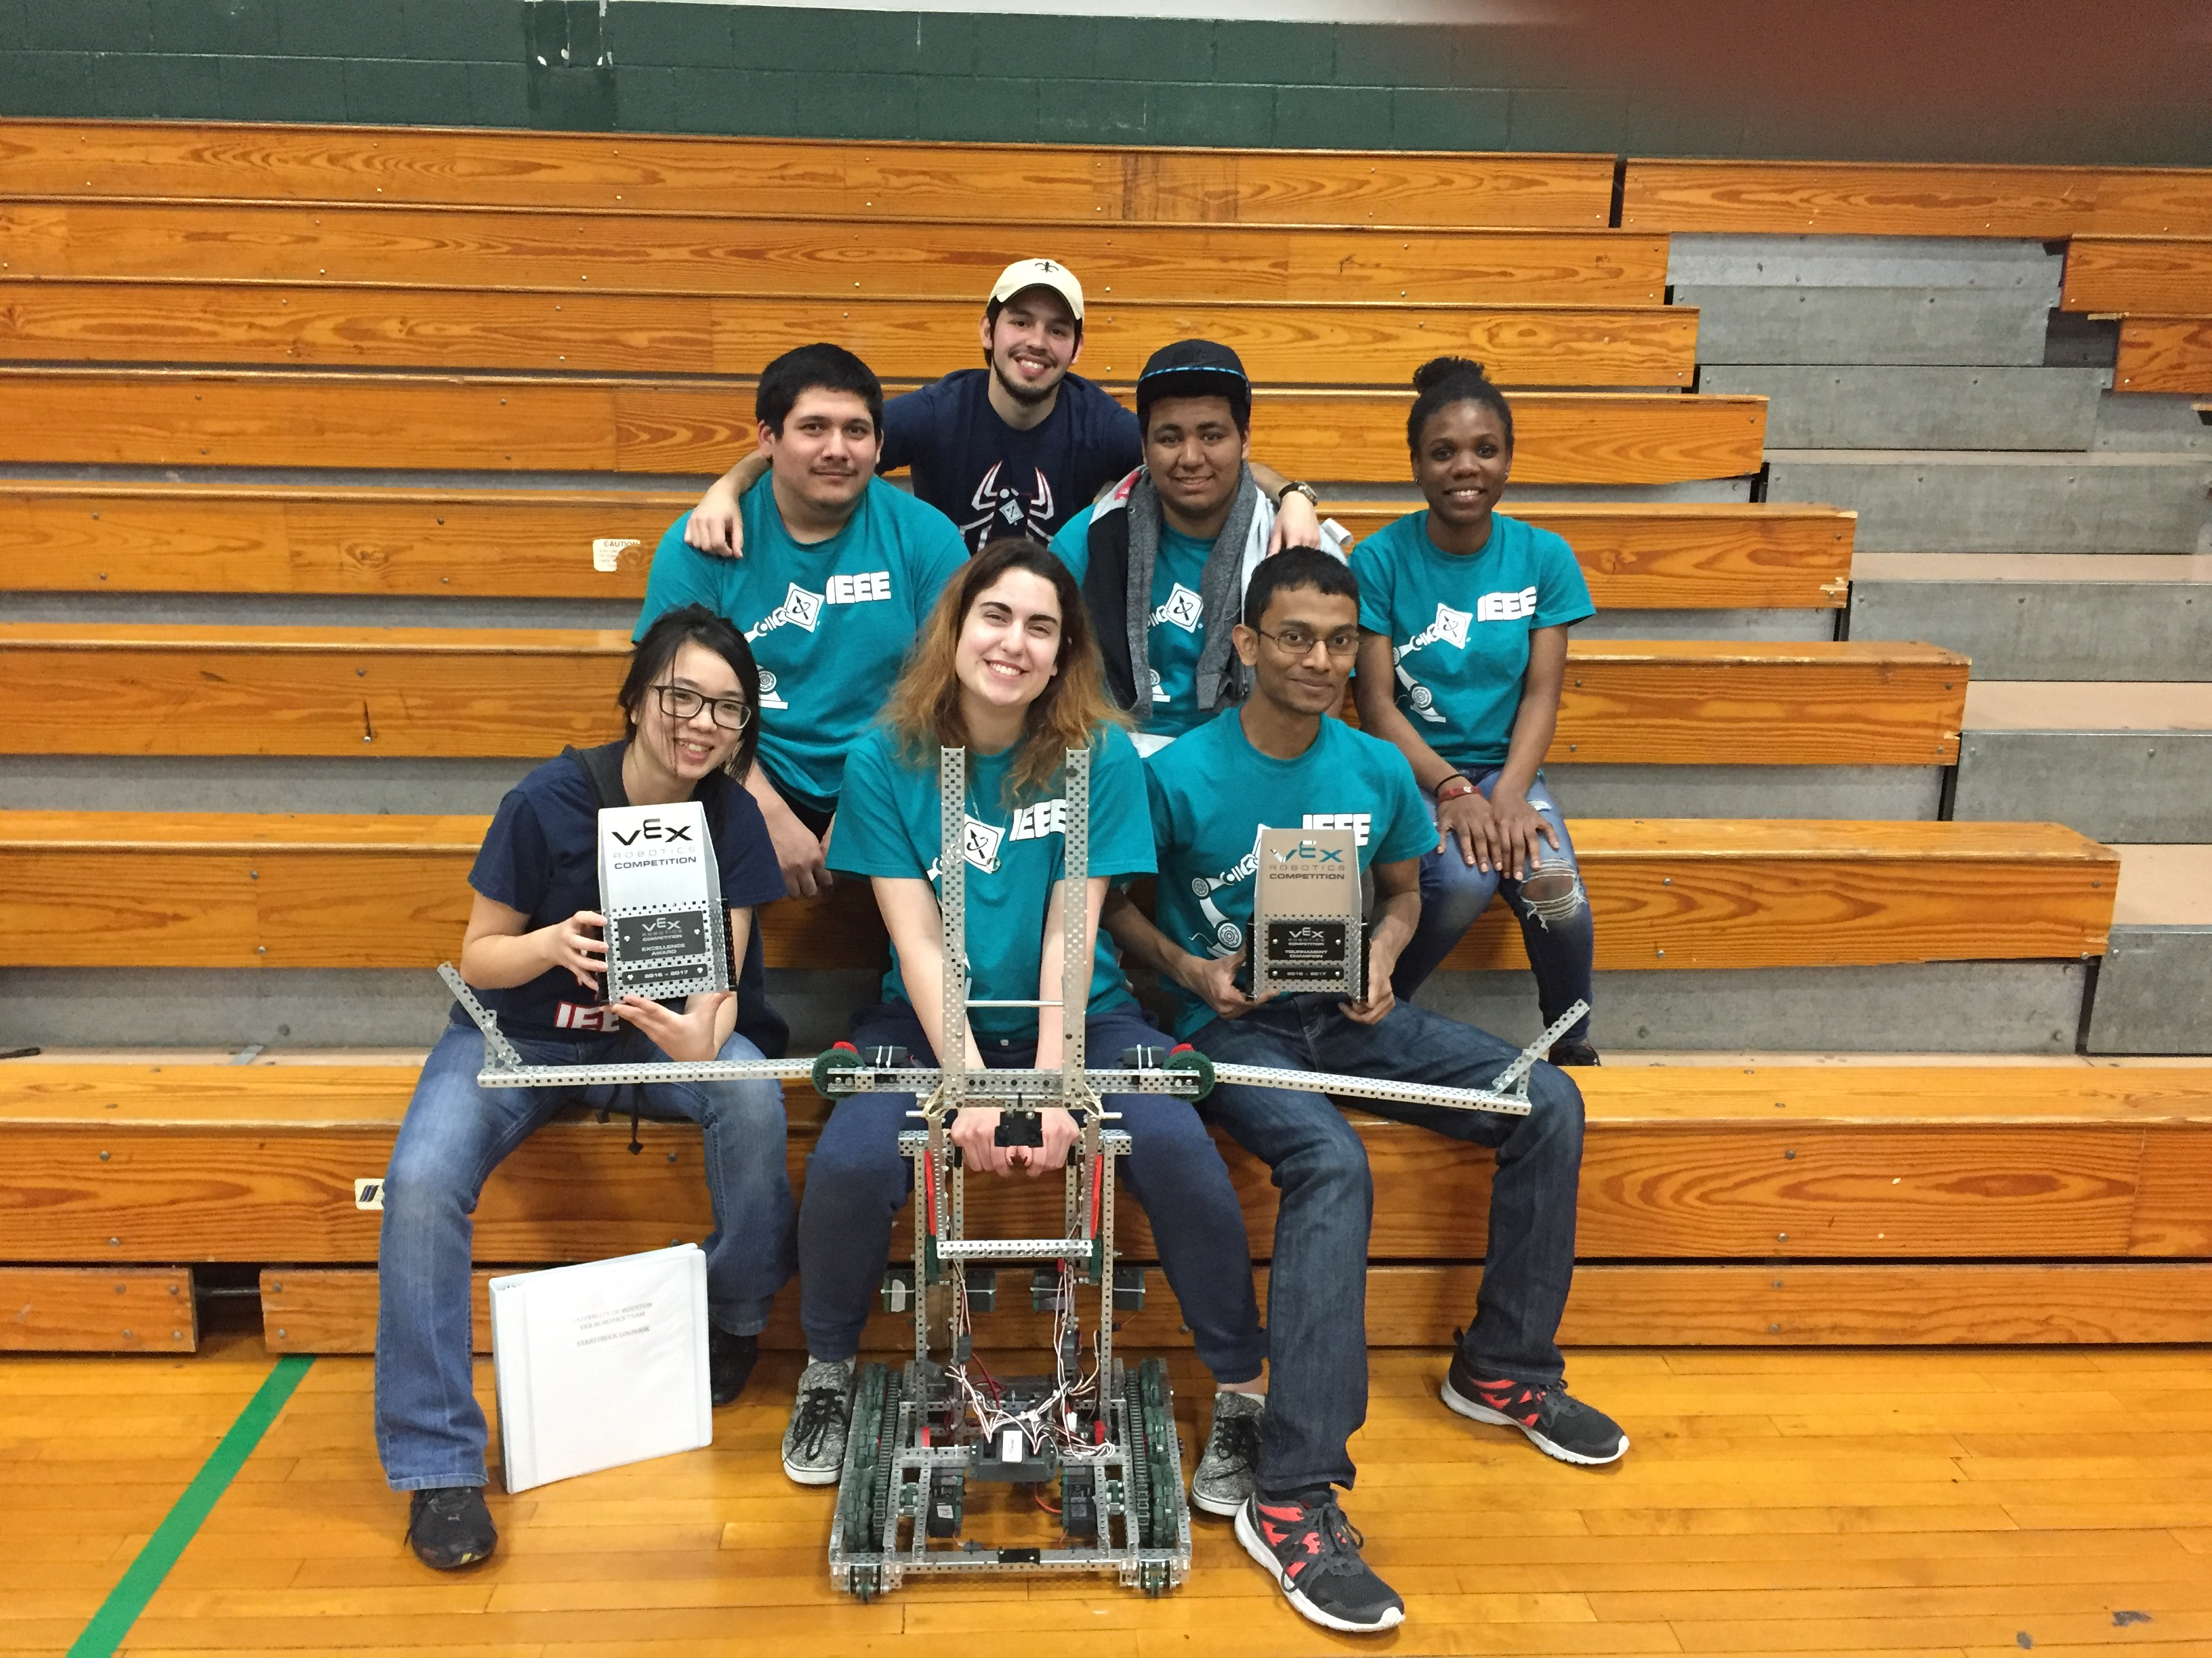

Figure - Look at those happy faces

* 1. Project 3: <Other>
     1. Helped Javier with his bar model
        1. Speculated on how laser cutter works w/ Javier
           1. So the bounds of the laser cutter is 1ft and Javier asked the laser cutter to make a 1ft by 1ft square
           2. The plastic we have is actually 11 7/8 in
           3. However, when the laser cutter is set to it’s 1ft by 1ft bounds, it cuts along the edge of the plastic creating a piece that is 11 ¾ in
        2. Assembly takes two people

1. **My *Goals* for next week**
   1. (Let’s set the bar lower so I stop failing) Find a sensor that actually senses kilobots
2. **Needed from Dr Becker**
   1. Nothing